|  |  |
| --- | --- |
| Customer churn modelling | **Youssef Mohamed**  [Tableau Practicing] |

# **Q1: show the number of customers on the map**

# **Q2: create an AB testing for these categories (people that leave)**

## [1] Age bins of 10

## [2] Salary bins of 10000k

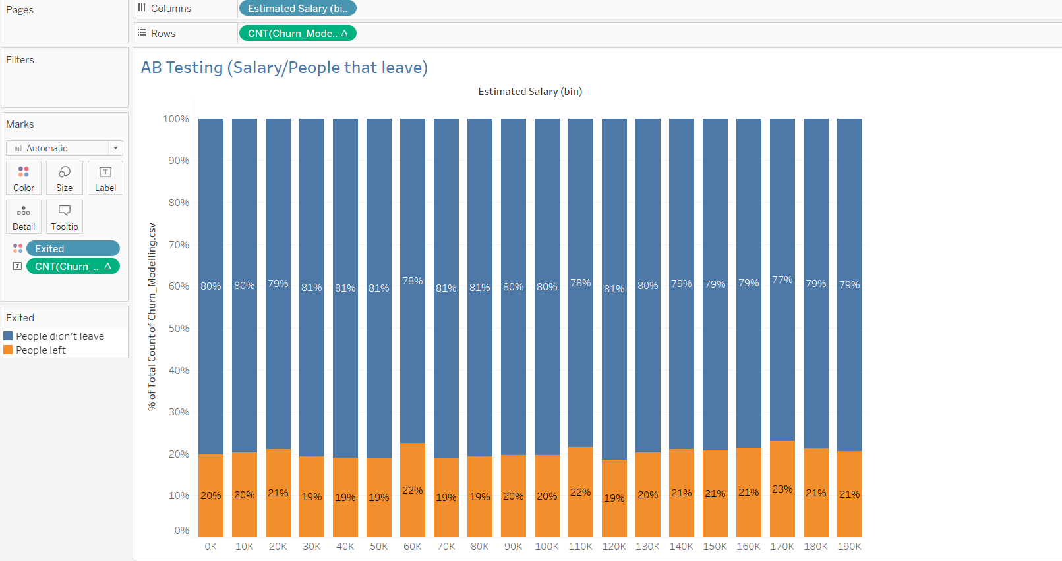

## [3] Number of Products

## [4] Gender

# **Some business decisions to benefit this business**

* Increase investments in France.
* According to the AB testing above, the best age bins to target are 10 to 30.
* Concerning the salary, salary has nothing to affect our business and that’s due to the small variance between the bins.
* Product number 2 is the best product to invest in.
* Targeting males is better than targeting females.